**Android**

**History : by sneha**

While Apple’s iOS is arguably the world’s first smartphone operating system, Google’s Android is by far the most popular. Android has evolved significantly since its inception, first being released on an HTC-made T-Mobile device back in 2008. Some might not know, however, that Android’s history dates back before it was available on smartphones. However, it’s actually been less than 10 years since the first official Android phone made its debut for consumers to buy in stores. Google’s decision to make Android an open source OS allowed it to become highly popular with third-party phone makers. Just a few years after the launch of Android 1.0, Smartphones that had the OS installed were everywhere. Now it has become the most popular mobile OS in the world, defeating its many competitors like Symbian, BlackBerry, Palm OS, web OS, and Windows Phone. Apple’s iOS is the only platform still standing as a serious competitor to Android and that situation doesn’t look like it will change anytime soon.

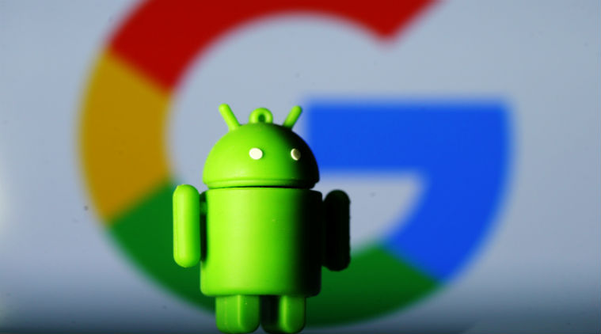

In October 2003, well before the term “smartphone” was used by most of the public, and several years before Apple announced its first iPhone and its iOS, the company Android Inc. was founded in Palo Alto, California. Its four founders were Rich Miner, Nick Sears, Chris White, and Andy Rubin. At the time of its public founding, Rubin was quoted as saying that Android Inc. was going to develop “smarter mobile devices that are more aware of its owner’s location and preferences.”

In fact, Android was first created in 2003 by Andy Rubin, who first started developing the OS for digital cameras. Soon, he realized that the market for digital camera operating systems perhaps wasn’t all that big, and Android, Inc. diverted its attention toward smartphones. It wasn’t until 2005 that Google purchased Android, Inc., and while not much about Android was known at the time, many took it as a signal that Google would use the platform to enter the phone business. Eventually, Google did enter the smartphone business — but not as a hardware manufacturer. Instead, it marketed Android to other manufacturers, first catching the eye of HTC, who used the platform for the first Android phone, the HTC Dream, in 2008.

**The founding of Android: by sneha**

While that sounds like the basic description of a smartphone, Rubin revealed in a 2013 speech in Tokyo that Android OS was originally meant to improve the operating systems of digital cameras, as reported by PC World. The company made pitches to investors in 2004 that showed how Android, installed on a camera, would connect wirelessly to a PC. That PC would then connect to an “Android Datacentre,” where camera owners could store their photos online on a cloud server.

Obviously, the team at Android didn’t think at first about creating an OS that would serve as the heart of a complete mobile computing system on its own. But even back then, the market for stand-alone digital cameras was declining, and a few months later, Android Inc. decided to shift gears towards using the OS inside mobile phones. As Rubin said in 2013,“The exact same platform, the exact same operating system we built for cameras, that became Android for cell phones.”

In 2005, the next big chapter in Android’s history was made when the original company was acquired by Google. Rubin and other founding members stayed on to continue to develop the OS under their new owners. The decision was made to use Linux as the basis for the Android OS, and that also meant that Android itself could be offered to third-party mobile phone manufacturers for free. Google and the Android team felt the company could make money offering other services that used the OS, including apps.

Rubin stayed at Google as head of the Android team until 2013, when Google announced he would be leaving that division. In late 2014, Rubin left Google altogether and launched a start-up business incubator. Earlier in 2017,

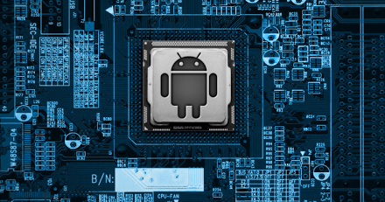

Rubin officially revealed his return to the smartphone industry with his company’s announcement of the Android-based Essential Phone. And then year by year android went on upgrading their features by modifications in earlier versions with new innovations added to it.

**License: by sneha**

The source code for Android is open-source. It is developed in private by Google. For the purposes of licensing, the Android content is divided into two categories:

1. Documentation content, including both static documentation and content extracted from source code modules, as well as sample code, and
2. All other site content

The documentation content is made available to you as part of the Android Open Source Project. This documentation, including any code shown in it, is licensed under the Apache 2.0 license, the preferred license for all parts of the of the Android Open Source Project.

Apache 2.0 is a commercial and open-source-friendly software license. The majority of the Android platform and documentation is licensed under the Apache 2.0 license. While the project strives to adhere to the preferred license, there may be exceptions, such as for documentation (code comments) extracted from a source code module that is licensed under GPLv2 or other license. In those cases, the license covering the source code module will apply to the documentation extracted from it. Source code modules that are used in the generation of documentation and have licenses that require attribution can be found in the Documentation Licences section below.

Third-party components such as JavaScript libraries are included in the Android Open Source Project under the licenses specified by their authors. For information about these licenses, refer to the source files in the Android Open Source Project.

All other content, except the license documents themselves and as otherwise noted, is licensed under the Creative Commons Attribution 3.0 license.

**Version list: by sneha**

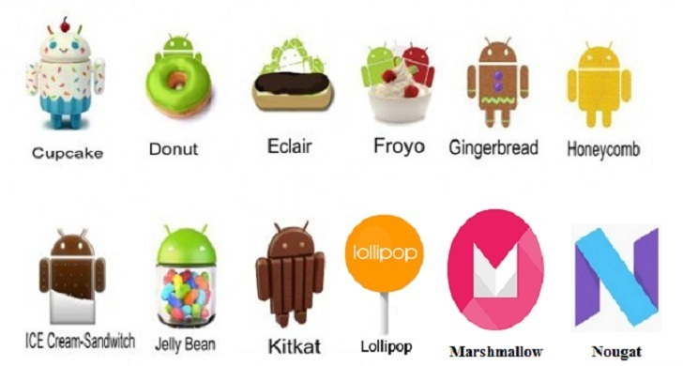

Android 1 Alpha

Android 1 Beta

Android 1.5 Cupcake

Android 1.6 Donut

Android 2.0 and 2.1 Éclair

Android 2.2 Froyo

Android 2.3 Gingerbread

Android 3.0 and 3.1 Honeycomb

Android 4.0 Ice Cream Sandwich

Android 4.1, 4.2 and 4.3 Jellybean

Android 4.4 Kit Kat

Android 5.0 Lollipop

Android 6.0 Marshmallow

Android 7.0 Nougat

Android 8.0 Oreo

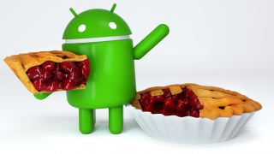

**Mascot: by sneha**

The well-known Android mascot is called Bugdroid. But it is not the original, very first Android mascot. Dan Morrill, head of developer relations for the platform, had to present a slide for the internal developer launch of Android. As a last-minute solution, he started to draw a mascot with Inkscape software, and the mascot called Dandroid was born.

When [Irina Blok](http://www.irinablok.com/) came up with the idea to create a simple green robot to symbolize what was one of Google's newest projects at the time, she had no idea it would become so iconic.

The Dandroids experienced a period of popularity around Google’s offices, but shortly thereafter, Irina Blok came through with her brilliant Bugdroid design that has become the face of the operating system. Irina Block is a professional designer, art director.

Irina Blok may have drawn one of the most recognized logos in the world, but her association with the green Android has not made her famous. Blok can think of only one incident when she garnered the public’s attention for designing it. In 2010, she and her 6-year-old daughter were in a movie theater waiting for “Alice in Wonderland” to begin when an Android logo flashed on the screen. Her daughter, Blok recalls, suddenly stood up and yelled, “My mommy invented that!” Everyone in the row in front of them turned around to stare. Blok was so embarrassed, she says, that she sank down behind her tub of popcorn.

The Bugdroid logo was born, when Blok worked as a designer at Google. As Google prepared to endorse the Android software platform for mobile devices, Blok and her design-team colleagues were told to create a look for the software — something that consumers could easily identify. The logo, she was told, should involve a robot, and so she studied sci-fi toys and space movies — anything that might help her create a character. In the end, she took inspiration from a distinctly human source: the pictograms of the universal man and woman that often appear on restroom doors. She drew a stripped-down robot with a tin-can-shaped torso and antennas on his head.

While Blok worked on her design, she and her colleagues agreed that the logo, like the software, should be open-sourced. “We decided it would be a collaborative logo that everybody in the world could customize,” she says. “That was pretty daring.” Most companies, of course, defend their trademark from copycats, and million-dollar lawsuits have been filed over the rights to corporate insignia. This one would remain free.

In the years since, the Android logo has been dressed up as a ninja, given skis and skateboards and even transformed into a limited-edition Kit-Kat bar. Blok (who is now creative director at Edmodo, a social network for students and teachers) says that creating the logo was like raising a child: “You give a life to this individual, and then they have a life of their own.”

Today, the little green robot that Google uses as the mascot for Android may be one of the most widely recognizable logos in the tech industry.

